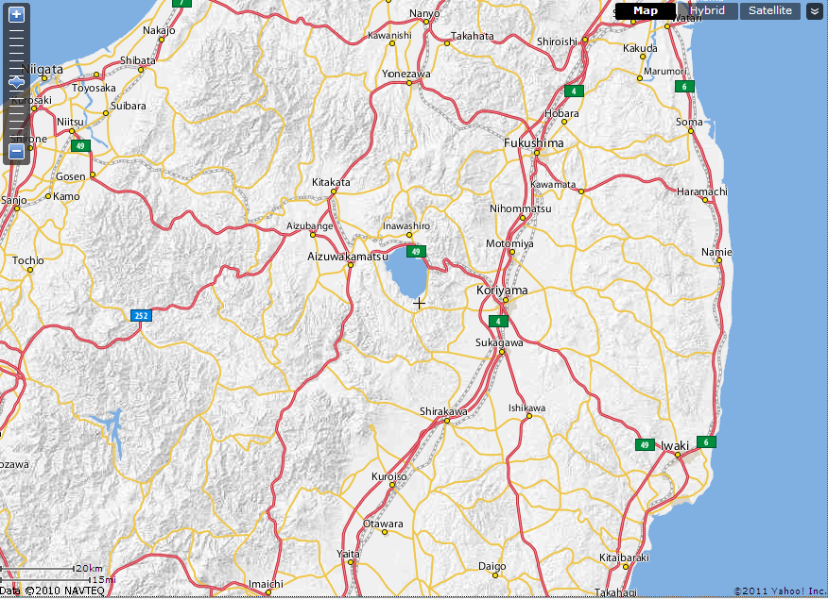
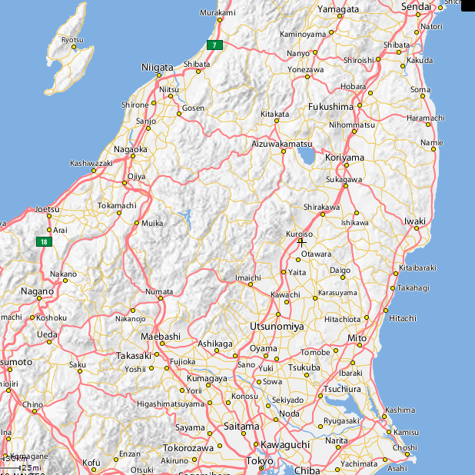
30km
Information purpose only
Fukushima Daini
Fukushima Daiichi
10km
20km

